Confirmation Date unable to select from date picker-UAT Neurology prod issue replication)

#1 Cancel Request

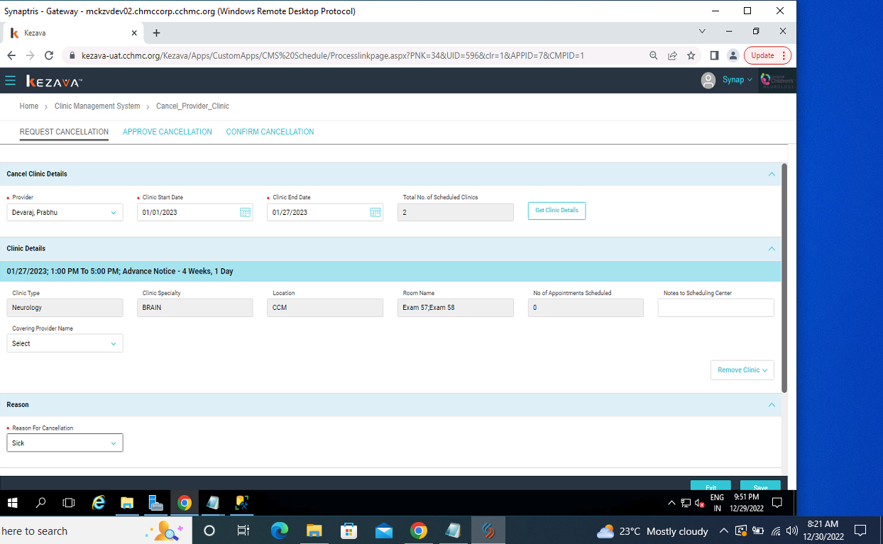

#2 Cancel request-Confirmation stage

